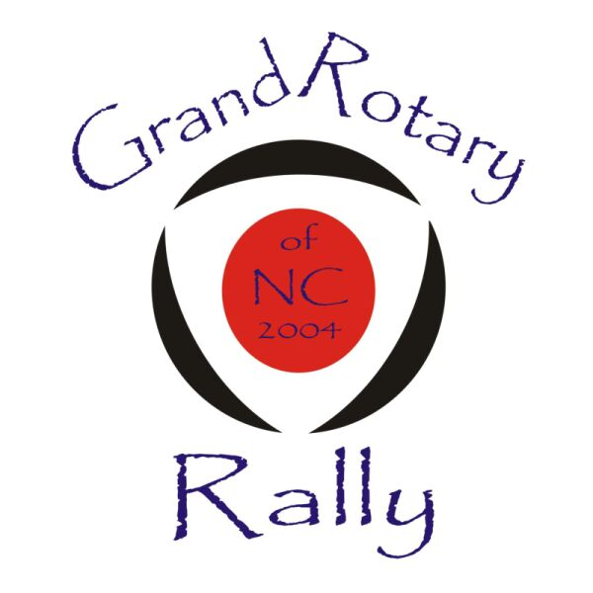

LIST OF COMMITTED ROTARIANS
1. NCTII87, Dave
2. Smoken’, Steve
3. Ken
4. JMumilla94RX7, Josh
5. zooooom, Johny
6. FD3sAutobot, Ryan,
7. GTUser, Bert,
8. dubcaps,
9. arghx, Ray
10. TurboII, Greg
11. Batguano, Lee,
12. Rotorfire, Mike (CP)
13. Poor red neck,
14. Marc01, Marc (CP)
15. FBII,
16. allforJesus06, Chris
17. implusive-rx,7 (Camp Lejeune)
18. Puntorotary, Jack (Jacksonville)

??ROTARIANS THAT MAYBE GONNA COME??
1. tookwik, Taylor
2. JKM, Joey
3. Red Blast, Lauren
4. Jayseven,
5. LaCan91,
6. 82SilverRX7,
7. 10thanniversaryrx7,
8. rotarymike, Mike
9. MaxDuo,

There are also several RX8 owners that are planning to attend, 3 definites and a couple of probables. I haven’t had the time to firm these up yet, Bobby is also working on that side of the rotary world.

